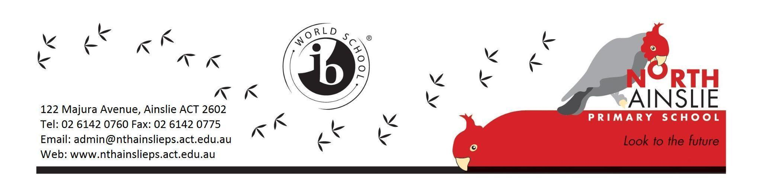
TERM 2 OVERVIEW - PRESCHOOL

Welcome to term 2 of preschool for 2024! We have updated all of the information in this new term overview, please ensure you read through each of the sections.

Preschool Teachers: Diane Newton & Cassandra Green

Preschool Educators: Marie Kuipers & Karen Merryfull

School Leader: Charissa Gosper

Release Teachers/LSAs: Hayley Skipper, Amy Pepper, Sarah Buckley & Jane Stainthorpe.

GENERAL INFORMATION
- Children are still required to bring a sun smart hat clearly labelled with their name. These are left at school in their pocket.
- As the weather is beginning to cool down, please ensure you send your children in a clearly labelled jumper and coat.
- A reminder that there are lots of opportunities for running, jumping, balancing and climbing at preschool. Please ensure your children are wearing appropriate footwear to support these fundamental movement skills.
- Children need to bring a water bottle each day clearly labelled with their name.
- Wash hands when you enter the preschool in the morning.
- Don’t forget to check pockets on your way out for notes and amazing artworks!

COMMUNICATION
We would like to support families by reminding you about the best ways to communicate with us. Please read below to see the different reasons you may have for contacting the school and the processes you use for each situation. Just a reminder that messaging on Class Dojo is no longer being used here at North Ainslie Primary School.
Communication with parents and carers is important to us and our staff will always work to get back to your enquiries within a reasonable timeframe. There is no expectation that teachers respond to queries from families during their personal and family time.

We update families on what is happening at our school in a number of ways from information nights, emails, notes, newsletters, and Dojo. We encourage you to stay in touch with what is happening in our school through these channels.

Remember that our front office is a vital part of our communication strategy and is often a great first port of call. They can be contacted:
- by phone on 61420760 or
- via an email to admin@nthainslieps.act.edu.au

By using these processes, you also ensure the right information is getting to the right staff member in the most timely and efficient manner.
Reason: | Please contact:
General Enquiries  - Permission notes  - Enrolment enquiries  - After school clubs | The Front Office on 6142 0760 or via email: admin@nthainslieps.act.edu.au
Student Absences | On the day:  - Use the parent portal (if contacting the school before 9:15am as this will stop you receiving an SMS from the school)  - Email to absence@nthainslieps.act.edu.au  - Respond to the SMS from the school  Past or future:  - Use the parent portal  - Email to absence@nthainslieps.act.edu.au
Late arrivals, early pickups and changes to arrangements for your child | In advance  - Please email the front office, at least 48 hours in advance using the absence email address: absence@nthainslieps.act.edu.au  - This will ensure the communication is passed on to the teachers  Unexpected and on the day  - Please phone the front office on 6142 0760  *Please do not contact teachers directly as there is no guarantee they will see the communication in time.
The welfare or academic progress of your child | In the first instance  - For any information regarding your child, please contact their class teacher in the first instance via email. All teacher’s email addresses are firstname.lastname@ed.act.edu.au  or  - Contact the school leader for your child’s year level via their email address: firstname.lastname@ed.act.edu.au  or  - Contact the school front office via 6142 0760 or email: admin@nthainslieps.act.edu.au and they will direct you to the appropriate person or have someone contact you.
Concerns or enquiries | Please contact the front office via email admin@nthainslieps.act.edu.au or call 6142 0760 for all general all:  - General questions regarding excursions and school activities  - Non classroom related concerns or incidents  - To make an appointment with a member of the leadership team  This will ensure the communication is passed on and responded to as quickly as possible.

Staff responding to communication
Communication with parents and carers is important to us and our staff will always work to get back to your enquiries within a reasonable timeframe. We aim to do this within three working days. There is no expectation that teachers respond to queries from families during their personal and family time.If your matter is urgent please contact the front office rather than the classroom teacher. This will ensure we can get back to you as quickly as possible.

STAYING HOME IF UNWELL
As we approach winter and the colder weather, we remind families that if your child becomes unwell to please not send them to preschool until their symptoms have resolved.

This winter we are again expecting to see a higher number of staff away due to seasonal illness, as will be the case across all workplaces. While these short-term absences cannot be entirely avoided, we can all play our part in minimising the spread of disease by doing the right thing.

Unfortunately, short-term staff absences due to illness can have an impact on the way we deliver our program and in some cases this will mean a change in teaching staff. We understand that these changes can be difficult for some children and we will endeavour to provide as much consistency as possible.
These temporary adjustments support us to ensure student learning is not impacted, and if any changes are made we will keep you updated.

TERM 2 LEARNING FOCUSES
Below is a brief overview of our learning for Term 2. More information about our preschools can be found here: Preschool 2024 Information
Social and Emotional Development | Developing relationships and friendships through communicating, collaborating and cooperating with others  Continue to develop a sense of belonging to NAPS/Hackett preschool, educators and peers  Identifying emotions and feelings
Literacy Focuses | Opportunities for authentic literacy experiences, including experimental writing and drawing  Listening to and identifying sounds in their name  Vocabulary development, verbally sharing and listening to others  Listening and responding to a variety of rich text types  Singing and rhyming  ELLA (Early Learning Languages Australia Programme)
Numeracy Focuses | Authentic hands-on mathematical experiences, including spatial reasoning toys such as blocks, Lego, puzzles and box construction  Counting through songs and authentic counting opportunities  - Recognising and identifying 2D shapes in the environment
Unit of Inquiry | How we express ourselves  Central idea: People express their ideas and feelings through the arts.  Lines of inquiry:  Expression of ideas, feelings, culture and meaning through the arts.  Different forms of art.  Artworks are developed through the use of different techniques and processes.  We will also continue to incorporate our term 1 inquiry ‘Who we are’ into our program as we reflect on the central idea, ‘I can learn more about myself, where and with whom I belong and how I will change’.

Thank you,
The Preschool Team
Diane Newton (NAPS site) diane.newton@ed.act.edu.au
Cassandra Green (Hackett site) cassandra.green@ed.act.edu.au
Charissa Gosper (School Leader - Pre/K) charissa.gosper@ed.act.edu.au

