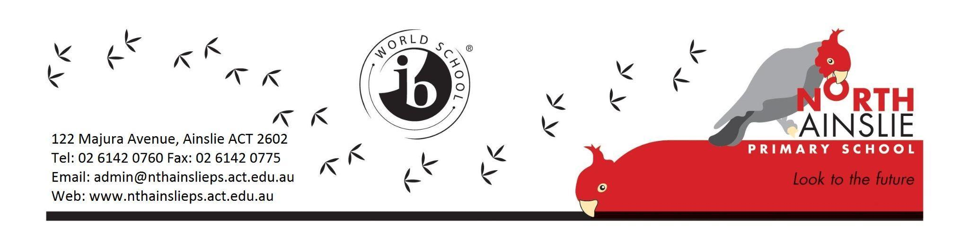
TERM 4 OVERVIEW - Junior IEC

Welcome to the Junior IEC 2023! This is a ‘term overview’. It explains what our class will be doing this term.
Your child’s teachers: Travis Thurston (travis.thurston@ed.act.edu.au, or on ClassDojo)
Release Teachers: Alison Hicks (library), Amy Pepper (PACH), Andrea Campbell (music)
School leader for IEC: Sharon Moloney

MONDAY MORNING YARN UP
On Monday morning all classes from Kinder to Year 6 line up behind their class name in the senior courtyard. The students learn about lunchtime clubs, upcoming events, and other activities at school.
Students in kindergarten to year 2 should not go to the junior playground on Monday mornings but should go to the senior courtyard. The teachers will help the students find where to go. The teachers will meet them there when the bell rings.
All classes then go to their classes from the morning lines.

WHAT TO BRING TO SCHOOL EVERY DAY
- A sun smart hat
- A drink bottle
- Shoes for sport

COMMUNICATION
- We use emails and notes home, phone calls, Class Dojo (for both class and whole school information) and our newsletter - The Gang Gang Gazette.
- Below is some brief information to help you communicate with the right person to help you within our school.

Reason: | Please contact:
General Enquiries  - Permission notes  - Enrolment enquiries  - After school clubs | The Front Office on 6142 0760 or via email: admin@nthainslieps.act.edu.au  You can ask for a telephone interpreter at the Front Office.
Student Absences | To inform the school about absences please contact the email address used specifically for absence notifications:  absence@nthainslieps.act.edu.au
Late arrivals, early pickups and changes to arrangements for your child | For pre-planned arrangement (known before the school day begins)  - Please contact your child’s teacher via a Class Dojo message or using their school email before 8.30am on the day: travis.thurston@ed.act.edu.au  If it is a last minute change to arrangements during the school day:  - Contact the school front office on 6142 0760 or via email admin@nthainslieps.act.edu.au  *Please note: Teachers may not check their email or Class Dojo throughout the day while teaching and the message cannot be guaranteed to reach your child in time.
The welfare or academic progress of your child | - Contact your child’s teacher via a Class Dojo message or using their school email: travis.thurston@ed.act.edu.au  Or  - Contact the school leader for your child’s year level via their email address: sharon.moloney@ed.act.edu.au  Or  - Contact the school front office via 6142 0760 or email: admin@nthainslieps.act.edu.au and they will direct you to the appropriate person or have someone contact you.

Staff responding to communication

We will do our best to check emails and Dojo messages every day before and after school - 8.30am until 5.00pm. You can expect a response within 48 hours. Emails or messages sent before or after work hours, or on weekends, will not be looked at until the following work day. If the matter is urgent, please call the Front Office who will then pass the message on to the staff member. They will then get back to you as soon as possible.

TERM 2 LEARNING FOCUSES
Primary Years Program ( PYP ) – Unit of Inquiry
How we express ourselves
Central Idea: We learn about ourselves and the world through stories.

Lines of Inquiry:
- An inquiry into what a story is
- An inquiry into the ways we discover feelings and emotions through literature
- An inquiry into how stories are shared

Literacy:
This term we will cover:
- Letter and sound relationships
- Explicit letter formation
- Speaking in front of the class
- Active listening skills
- Shared and modeled reading, and
- Guided reading and language rotations.

Books for home reading will go home every Monday. Try to read a book with your child every night. You can also ask questions about the pictures in the story: What do you see? What is happening in the picture?

Numeracy (Maths):
The topics we will explore this term are:
- Numbers to 20 for kindergarten
- Measurement: mass, capacity, and length
- Addition
- Data
- Days of the week

What does the week look like for the Junior IEC?*

Monday | Tuesday | Wednesday | Thursday | Friday
Book of the Week!  Library  with Kate  (Bring your book back to get another.)  Gardening  with Amy | We will learn about two new letters and their sounds a week, the first on Tuesday the second on Thursday. | Sport  We have sport every day. Please wear shoes for running. | Maths  We will have maths every day. Some days we will work on numbers, other days on other parts of the maths curriculum. | Music  with Andrea

*I will send a schedule on Class Dojo that shows what we will be doing each day.

Our Daily Routine:
Every day we will start with Investigations. Then we will have Literacy and Maths in the first two sessions of the day. Most afternoons the kindergarten students will have Choice Time, where they get to decide what they would like to do. Every day we will also have sport in the morning.

TERM 2 CALENDAR
Week 3 | - Tuesday 14 May - Cross Country  - Wednesday 15 May - Year 6 Peer Support Training  - Thursday 16 May - Back up Cross Country day  - Friday 17 May - Book Fair will be open for parents/carers to visit
Week 4 | - Monday 20 - Wednesday 22 May - Year 6 Camp at The Tops  - Friday 24 May - World Bee Day celebrations
Week 5  Reconciliation Week | - Monday 27 May - Reconciliation Day Public Holiday  - Friday 31 May - North Gungahlin Cross Country
Week 6
Week 7 | - Monday 10 June - King’s Birthday Public Holiday
Week 8 | - Monday 17 - Friday 21 June - Year 2 Swimming
Week 9
Week 10  NAIDOC Week (2-9 July) | - Monday 1 July - Reports Home  - Friday 5 July - Last Day of Term 2

Thank you,

Travis Thurston

