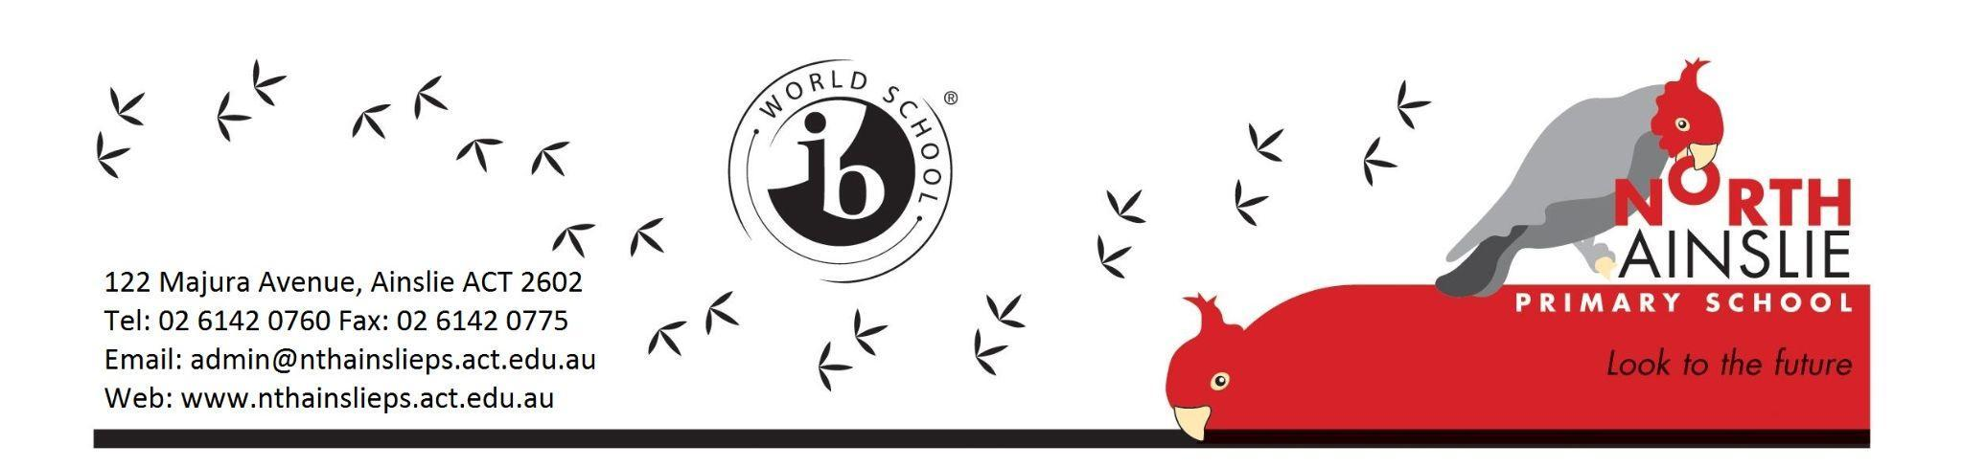
TERM 2 OVERVIEW - SENIOR IEC

Welcome to term 2 2024! This is a ‘term overview’. It explains what our class will be doing this term.

IEC Teachers: Mrs Isabel Winch
Specialist Teachers: Kristie Davies (Library) Andrea Campbell (Music) Amy Pepper (Gardening)
School leader for Year : Sharon Moloney (Deputy Principal)

GENERAL INFORMATION
- Children should not arrive before 8.45am
- If children arrive before 8.45am, they will need to sit down in the senior courtyard.
- If children arrive later than 9.10am, please see the staff in the front office.
- Our ‘Kiss and Drop’ on Sherbrooke St is for all children from 8.40-9.00am and from 3.00pm. It is for dropping children to school and picking them up in the afternoon from your car. Please drive to the front of the queue and do not park in the ‘Kiss and Drop’ area.
- Our break times are:
Recess - 11:00am - 11:30am

In-class eating time - 12:50pm - 1:00pm

Lunch - 1:00pm - 1:45pm

Please ensure that your child brings the following labelled items to school each day:
- A sun smart hat
- A drink bottle
- Sensible enclosed shoes for sport/P.E

MONDAY MORNING YARN UP

Every Monday, we have our whole school Yarn Up to start the week. The children sit down in front of the Owl picture in the Senior Courtyard by 9.00 am. Yarn Up is led by the year 6 Student Leaders. They share messages about lunchtime clubs, any upcoming events or other activities for the school.

COMMUNICATION
Communication with parents and carers is important to us and our staff will always work to get back to your enquiries within a reasonable timeframe. There is no expectation that teachers respond to queries from families during their personal and family time.

We update families on what is happening at our school in a number of ways from information nights, emails, notes, newsletters, and Dojo. We encourage you to stay in touch with what is happening in our school.

Reason: | Please contact:
General Enquiries  - Permission notes  - Enrolment enquiries  - After school clubs | The Front Office on 6142 0760 or via email: admin@nthainslieps.act.edu.au  You can ask for a telephone interpreter at the Front Office.
Student Absences | On the day:  - Email to absence@nthainslieps.act.edu.au  - Respond to the SMS from the school  Past or future:  - Email to absence@nthainslieps.act.edu.au
Late arrivals, early pickups and changes to arrangements for your child | Unexpected and on the day  - Please phone the front office on 6142 0760  *If you send me a Dojo Message I will probably not see this in time because I will be teaching!
The welfare or academic progress of your child | - For any information regarding your child, please contact Mrs Winch: Isabel.Winch@ed.act.edu.au  or  - Contact the school leader: Sharon.Moloney@ed.act.edu.au  or  - Contact the school front office on 6142 0760 or email: admin@nthainslieps.act.edu.au
Anything else | Please contact the front office admin@nthainslieps.act.edu.au or call 6142 0760 for:  - General questions about excursions and school activities  - Non classroom related concerns or incidents  - To make an appointment with a member of the leadership team

STAYING HOME IF UNWELL
As we approach winter and the colder weather, we remind families that if your child becomes unwell to please not send them to school until their symptoms have resolved.

This winter we are again expecting to see a higher number of staff away due to seasonal illness, as will be the case across all workplaces. While these short-term absences cannot be entirely avoided, we can all play our part in minimizing the spread of disease by doing the right thing.

Unfortunately, short-term staff absences due to illness can have an impact on the way we run our schools – and in some cases schools may need to temporarily adjust the delivery of programs in order to manage. This may include minor adjustments to school timetables, split classes, a reduction in extracurricular activities, camps and excursions, or periods of larger group or supervised independent learning. Teachers may use online educational resources as part of their teaching at school.

These temporary adjustments support schools to ensure student learning is not impacted, and if any changes are made we will keep you updated.

TERM 2 LEARNING FOCUSES
Below is a brief overview of our learning focuses for Term 2.
English Focuses | - Listening and speaking with an emphasis on retelling familiar events and stories  - Recognising and writing many of the sounds and letters of English  - Reading familiar texts  - Correct formation of letters in handwriting  - English language used for descriptions and for storytelling  Home Reading Program: Please send your child’s home reading folder to school each day. The children will change the book and read this with an adult, when possible.
Math Focuses | - Addition, subtraction, multiplication and division  - 2D and 3D shapes  - Data  - Measurement - mass, perimeter and area  We will focus on the English language required to understand these topics.
Primary Years Program (PYP)  Unit of Inquiry | How We Express Ourselves  Central idea: We learn about ourselves and the world through stories.  Lines of inquiry:  The ways that stories can be expressed  - The purpose of stories, such as teaching lessons  - The different ways we can share our stories

TERM 2 CALENDAR
Week 3 | - Tuesday 14 May - Cross Country  - Wednesday 15 May - Year 6 Peer Support Training  - Thursday 16 May - Back up Cross Country day  - Friday 17 May - Book Fair will be open for parents/carers to visit
Week 4 | - Monday 20 - Wednesday 22 May - Year 6 Camp at The Tops  - Friday 24 May - World Bee Day celebrations
Week 5  Reconciliation Week | - Monday 27 May - Reconciliation Day Public Holiday  - Friday 31 May - North Gungahlin Cross Country
Week 6
Week 7 | - Monday 10 June - King’s Birthday Public Holiday
Week 8 | - Monday 17 - Friday 21 June - Year 2 Swimming
Week 9
Week 10  NAIDOC Week (2-9 July) | - Monday 1 July - Reports Home  - Friday 5 July - Last Day of Term 2

WEEKLY TIMETABLE
Monday | Tuesday | Wednesday | Thursday | Friday
Literacy | Sport  Please wear running shoes  Literacy | Sport  Please wear running shoes  Literacy | Sport  Please wear running shoes  Literacy | Literacy  Gardening
Library  Please bring your library bag | Maths | Maths | Maths | Maths
Music | Reading  Unit of Inquiry | Reading  Unit of Inquiry | Reading  Unit of Inquiry | Reading  Unit of Inquiry

If you have any questions, please ask me. We look forward to a fun term of learning! Isabel

